**HCI Assignment – G1**

Due Date :

Group Members :

Ido Kadosh 301727277

Lee Hugi 311178552

Itay David 308021591

Raviv Komem 316217751

Lior Kauffman 315837997

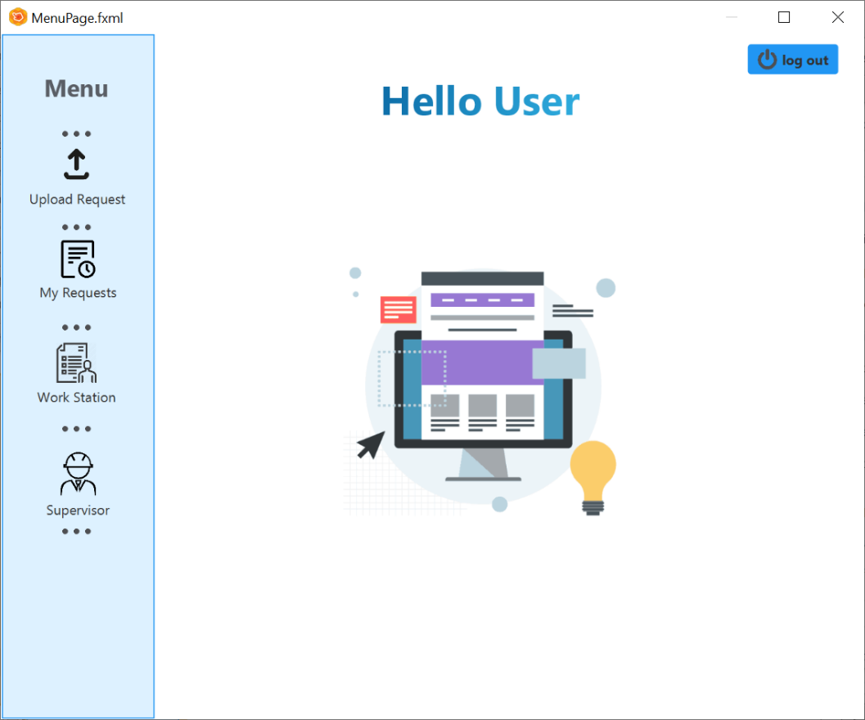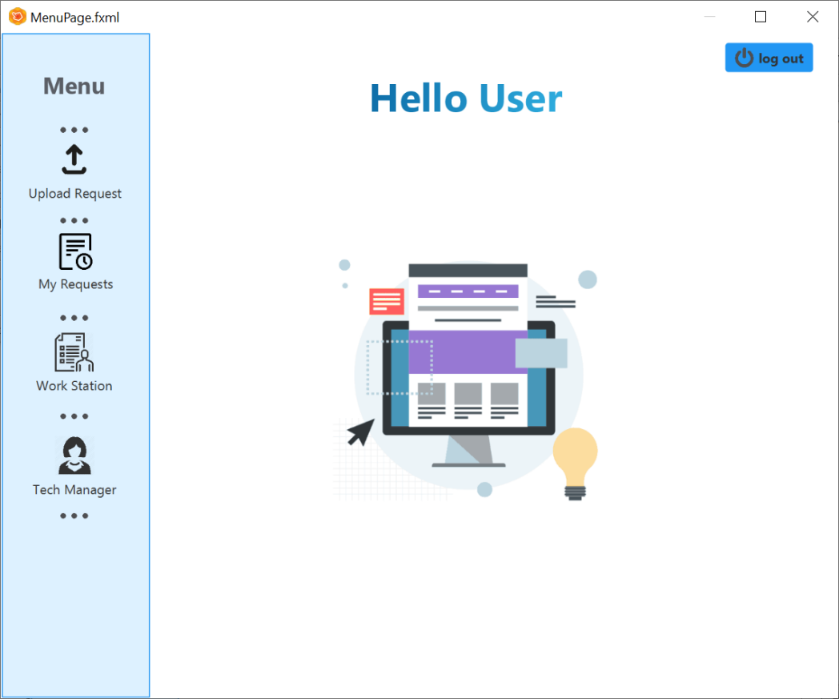

Only user with supervisor permission can see this button.

Only tech manager can see this button.

Only user with information engineer/tech manager permission can see this button.

Any logged in user can upload a change request.

And watch his change request.

Student can see only these two buttons.

Log out button will be in any page.

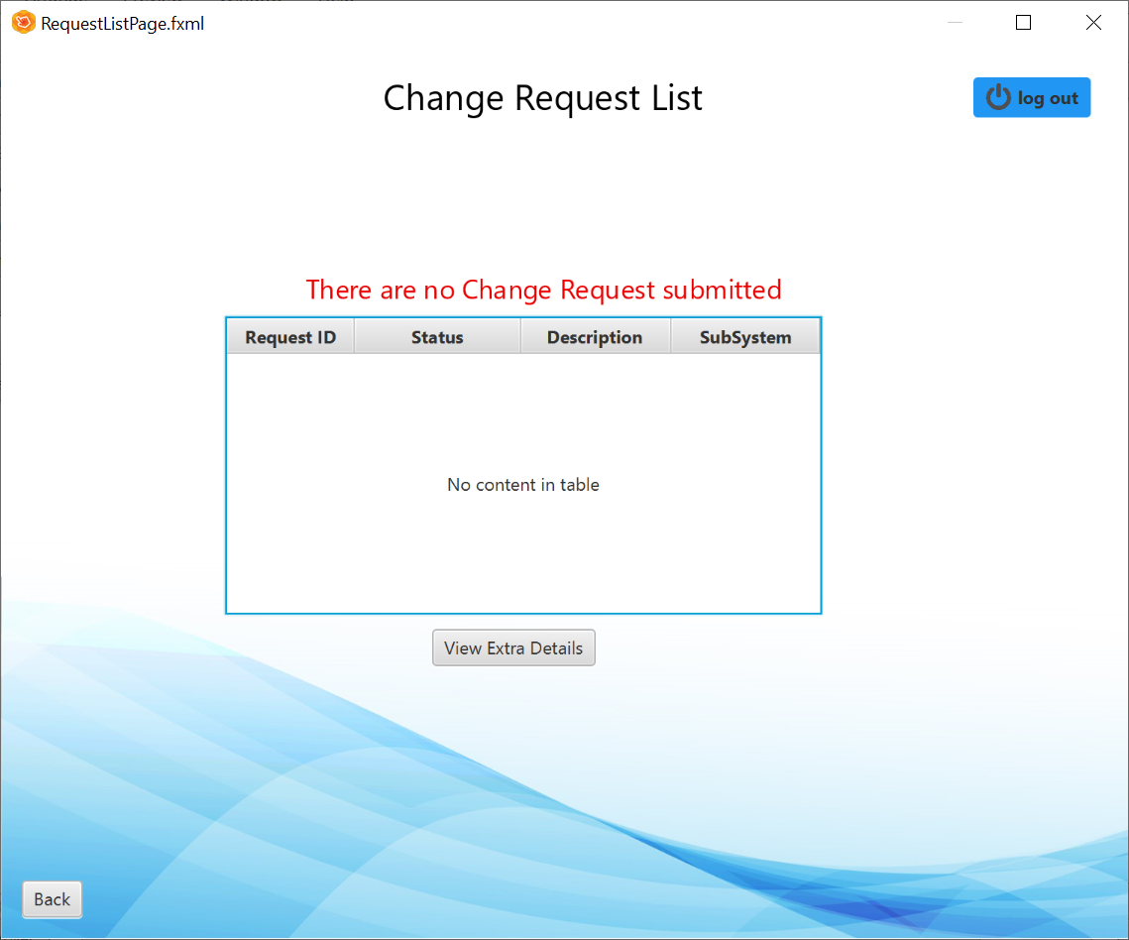Display change request details:

The table will show all the request that this user upload.

Incase user has no change requests submitted the system will show this message

By pressing this button, the user moves to an another page with extra details about a specific change request

Back button will be in any page.

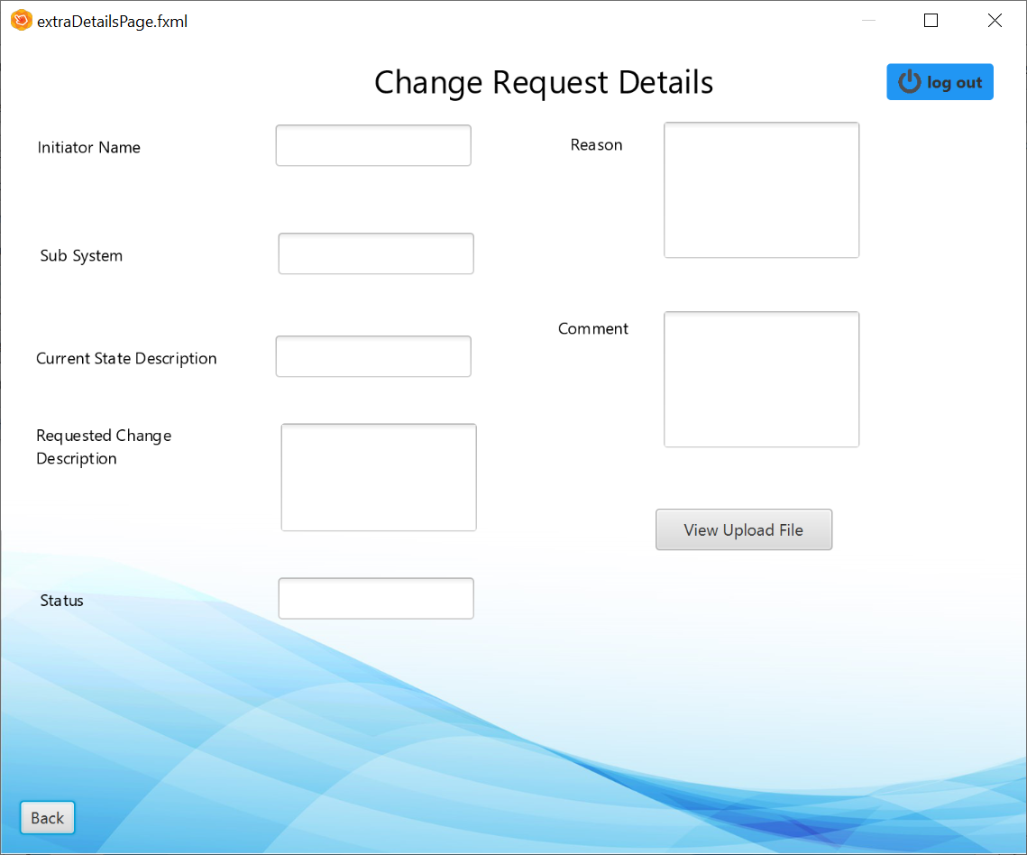

Incase user upload an extra file for a specific change request, this user can watch the file.

This page shows the extra details about the specific request.

Handle change request page:

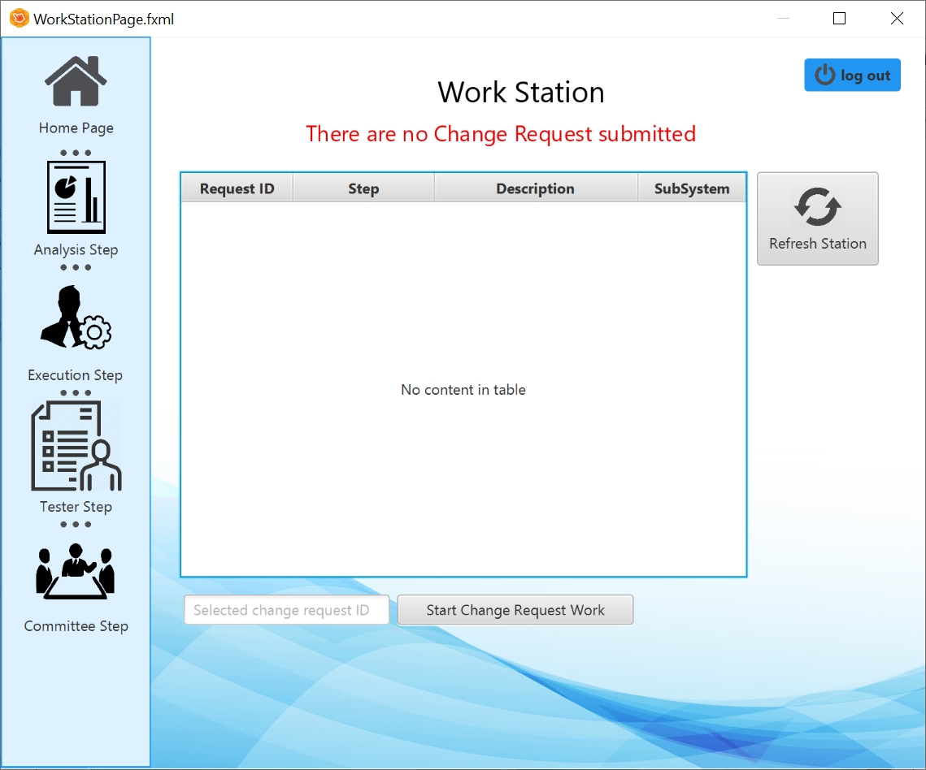

The table will show any request that information engineer need to handle with.

The buttons are filters to the table.

Tester step and committee step will show just to the committee member.

By click on a row in the table, the request ID will show up here.

This button refreshes the table.

After choosing the request the information engineer wants to handle, click here will move to the necessary page.

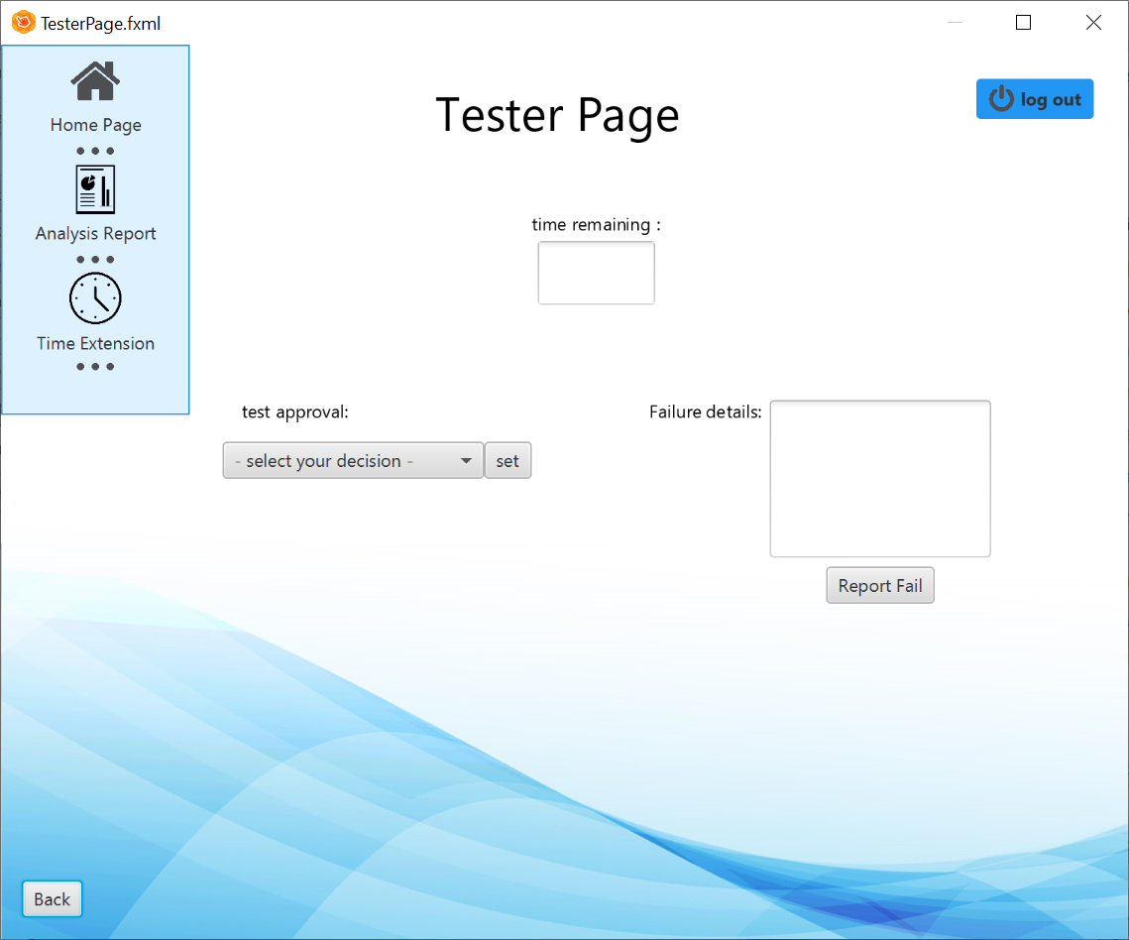

Choose the necessary button to watch the Analysis Report or ask for time extension.

Display a new page.

Incase of deny, the tester have to explain why the test failed.

Allow to choose one of the two options: approve or deny.

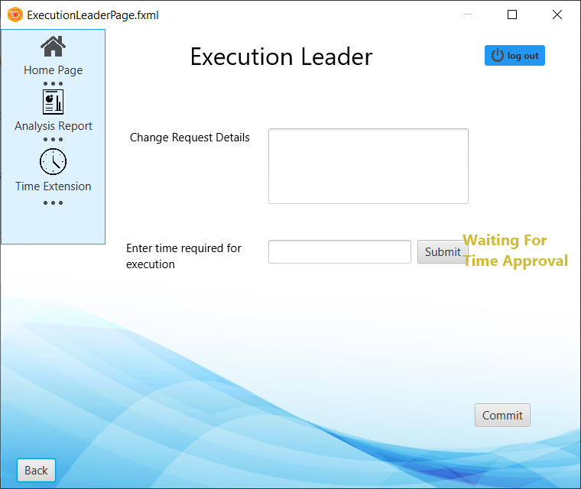

Incase the execution leader wants to view the analysis report or ask for a time extension for this current step.

Commit button for approval the finish work.

Before the execution leader starts the step, has to get approve for execution time from the supervisor.

Press submit after field the required time